Subject: SCIENCE AIR AND WATER
Check points
- A gas needed by us to breathe oxygen.
- The gas that forms the major part of the atmosphere nitrogen .
- The layer of atmosphere that contains ozone stratosphere .
- A gas that traps the Sun’s heat and holds it close to the Earth’s surface Carbon dioxide .
- The coldest layer of the atmosphere mesosphere .

A. Tick the correct answers.
1. What is the percentage of nitrogen in the atmosphere?
a) 77% b) 68% c)78% d)79%
2. Which gas is needed for burning?
a)nitrogen b)oxygen c)Carbon dioxide d)water vapour
3. Which layer of the atmosphere is closest to the surface of the Earth?
a)troposphereb)stratosphere c)mesosphere d)thermosphere
4.Which layer of the atmosphere absorbs the ultraviolet radiation from the Sun?
a)troposphere b) exosphere c)mesosphere d)stratosphere
5.Which layer of the atmosphere merges with the space?
a)troposphere b)exosphere c)mesosphere d)thermosphere

B. Fill in the blanks
1. Plants grow in the troposphere layer of the atmosphere.
2. The layer of atmosphere just above the mesosphere is thermosphere.
3. The layer of atmosphere just below the exosphere is thermosphere.
4. Filtration removes insoluble impurities from water.
5. Distilled water is the purest form of water.

C. Circle the odd one out.
1. Troposphere Oxygen Exosphere Mesosphere Thermosphere
2. Nitrogen Carbon dioxide Oxygen Plant Water vapour
3. Mustard seeds Pebbles Rice grains Sugar Glass beads
4. Boiling Chlorination Sedimentation Condensation

D. Give one word answers
1. Which gas is changed into its useful form by the roots of the pea and bean plants?
Ans: Nitrogen
2. Which gas is needed by green plants to make their food?
Ans: Carbon dioxide
3. Which gas acts like a shield and protects us from the harmful UV radiation of the Earth?
Ans: Ozone
4. Name one substance that is soluble in water.
Ans: Sugar / common salt
5.Which chemical is commonly added to disinfect water at home?
Ans: Chlorine

E. Write short answers
1. What are the different components of air?
Ans: Air is a mixture of gases. The different components of air are nitrogen, oxygen, carbon dioxide, water vapour and other gases such as argon, methane, nitrous oxide and sulphur dioxide. Smoke and dust particles are also present in the atmosphere
2. List two reasons why we need oxygen.
Ans:Living beings need oxygen for breathing. Oxygen is also needed for burning.
3. Why is mesosphere important to us?
Ans: Mesosphere is important to us because it burns and destroys the meteors that enter the atmosphere from space before they can strike the earth surface.
4. How does boiling makes water fit for drinking?
Ans: Boiling kills most of the germspresent in water. It also converts some soluble impurities into insoluble ones. These impurities settle at the bottom and sides of the container. These can be easily removed by filtration.
5.What is chlorination of water?
Ans: The process of killing germs present in water by adding small amount of chlorine to the water is called chlorination.
6.What is distilled water? What are its uses?
Ans: Distilled water is the purest form of water. It is used in science laboratories and in car batteries.

F. Answer these questions
1. List any three uses of nitrogen?
Ans: Three users of nitrogen are has follows
- Nitrogen is used to make fertilisers
- It is also used to keep packaged foods fresh
- Liquid nitrogen is very cold. It is used in laboratories , blood banks and food storage units to keep items freeze.
2. Show with the help of an experiment that air occupies space.
Ans: Take a balloon and blow air into it, it becomes bigger. This is because the air you blow into it needs space. So, it inflates the balloon. Also, it pushes against the wall of the balloon to make it grow larger. Now, if you release the mouth of the balloon, it collapse. The air inside the balloon escapes. Therefore, it returns to its original shape. This experiment shows that air occupies space.
3. Why is water important? If 70% of the Earth’s surface is covered with water, why do we need to save water?
Ans: Yes, all living organisms on the earth need water to survive. Water covers nearly 70% of the Earth’s surface. However, less than 1% of the total water is in the rivers, lakes and streams. The remaining water is found has ice and in the oceans. We cannot drink sea water as it is too salty. So, the water that is found in their rivers, lakes and streams has to be used by all living beings, animals and plants. If this water gets polluted and becomes unfit for drinking, we will run out of water. So water is important and we need to save water fixed
4. List the different methods used to remove soluble and insoluble impurities from water. Explain sedimentation and decantation.
Ans:Insoluble impurities are removed from water by sedimentation and decantation, and filtration. We can remove certain soluble impurities and kill germs present in the water by boiling and chlorination. Insoluble impurities are allowed to settle down at the bottom of a container of water. This process is called sedimentation. The impurities that settle down at the bottom are called sediments. The top layer of the clean water is gently poured into another container without disturbing the sediments. This process is called decantation.
5.Explain the process of distillation with the help of a labelled diagram. Give an example of distilled water found in nature.
Ans: The water is boiled to change into water vapour, leaving behind all the dissolved impurities. The vapours are collected or condensed in another container to obtain distilled water. The dew drop seen on leaves of plants early in the morning are an example of distilled water found in nature.
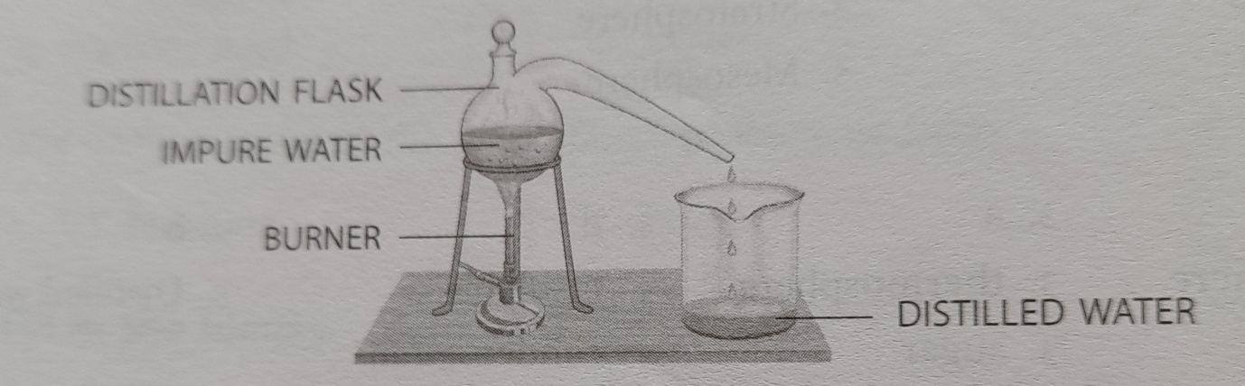
G
*

